1. What is Jquery?

The purpose of jQuery is to make it much easier to use JavaScript on your website. jQuery takes a lot of common tasks that require many lines of JavaScript code to accomplish, and wraps them into methods that you can call with a single line of code.

1. How to Apply CSS Using JQuery, How to Add Class and Remove Class in Jquery, JQuery Animation?

**Adding a class:**

$('selector').addClass(class_name);

**Removing a class:**

$('selector').removeClass(class_name);

Jquery Animation

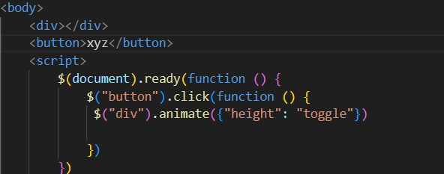

1. How to create slider with animation?

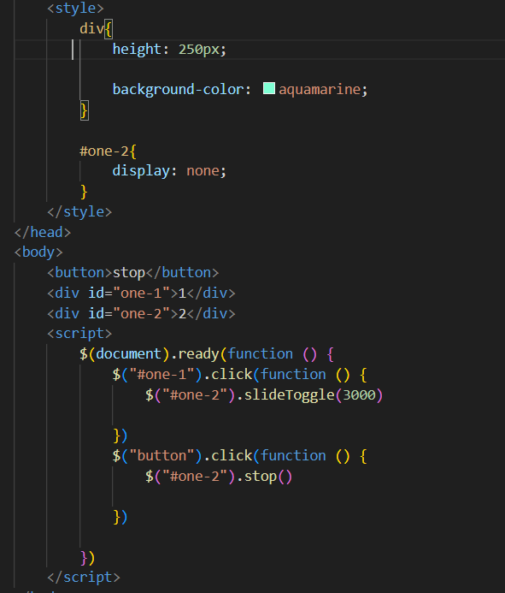

Practical:

Code

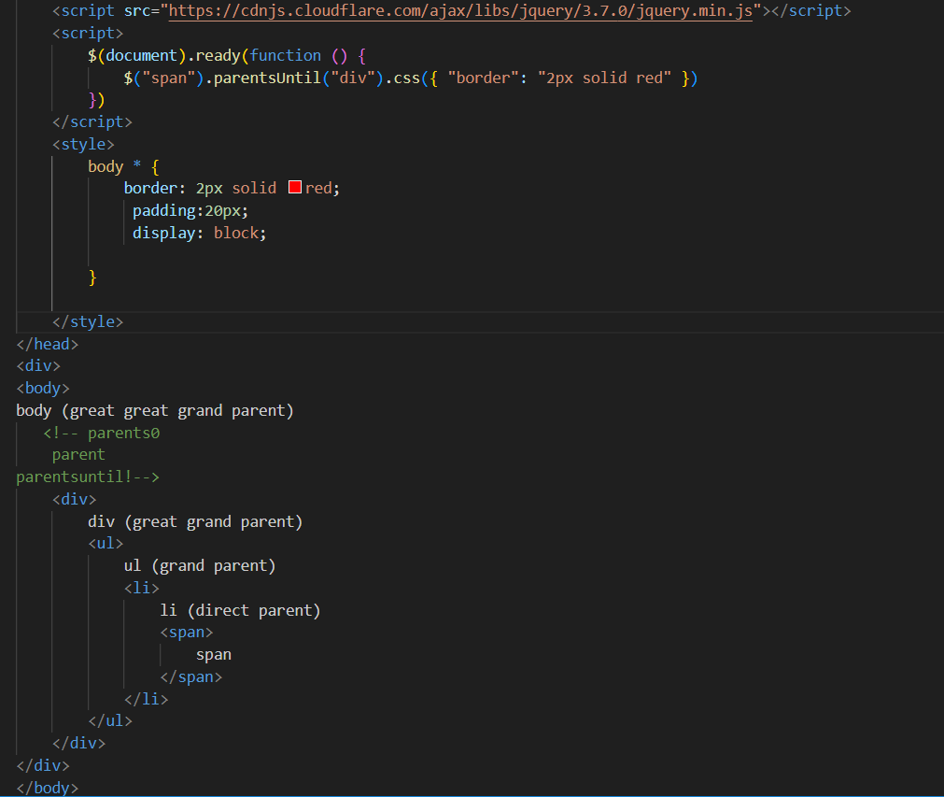

Output

